find—loe other cases:



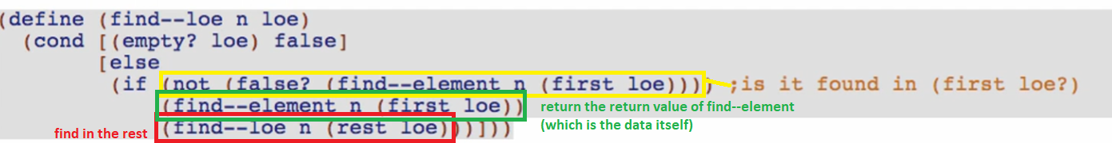

(not (false?) (…))

* Common for backtracking searches

Why is called backtracking?



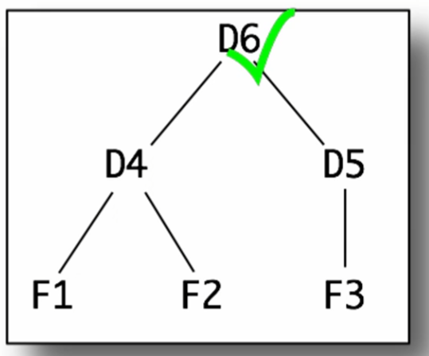



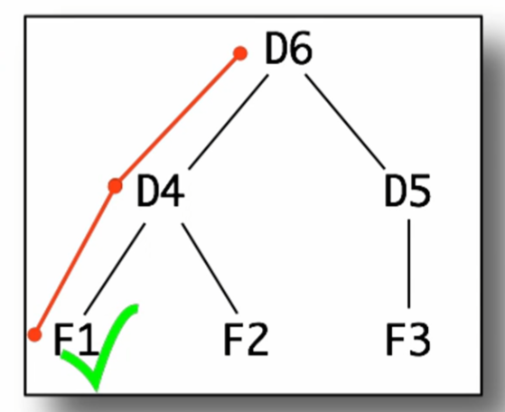



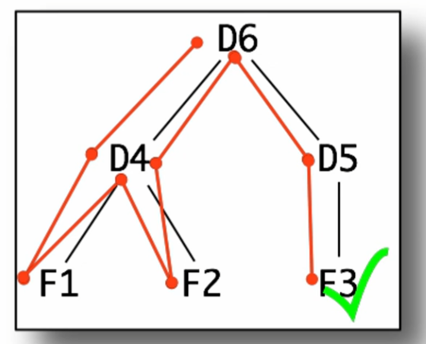

* Each time we get to a failing node/leaf (false), we go back to its parent and try the next child
  + We will fail completely if there are no parent already and the element is not yet found